Chocolate Easter Egg Treat Box

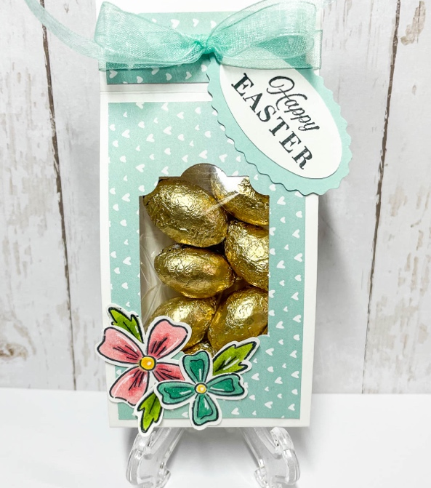
Supply List
Stamps | Flowers of Friendship & Celebrating You
Cardstock and Other Paper | Basic White, Pool Party, Sunshine & Rainbows DSP
Stampin’ Ink Pads | Memento Tuxedo Black
Tools & Other: | Everyday Label Punch, Double Oval Punch, and the Flowers of Friendship coordinating punch. Also, a small acetate bag – I use the size that fits an A2 card. (4 5/8” x 5 ¾”)
Embellishments | Pool Party Sheer Ribbon – about 12”
Adhesive | Tombo Liquid glue or tape adhesive, Foam dimensionals
Pens or Stampin’ Blends Markers | Flirty Flamingo, Bermuda Bay, Daffodil Delight & Granny Apple Green

Cutting Instructions:
Basic White | 2 ½” x 11”, and small scrap for sentiment that will be punched with double oval punch
Pool Party | Scrap 2” x 3” and punch with double oval scalloped punch
Sunshine & Rainbows DSP | 3 ⅞ x 2 ¼” (2), ¾” x 2 ¼” (2)

Assembly and Tips:
- Cut a piece of basic white 2 ½” x 11” and score on the long side at: 1”, 5 ⅛”, 5 ⅞” and 10”
- Cut your DSP – 2 pieces at 3 ⅞ x 2 ¼” and 2 pieces at ¾” x 2 ¼”
- Glue your DSP pieces down to your white base layer, center them in between your score lines. Leave the small middle section (which will be the bottom of your box) white.
- Fold and burnish along all the score lines.
- Using the everyday label punch, punch out the hole that will become the window for this treat box.
- Add your chocolate eggs to the cellophane bag and scoot them to the left side of the bag, making four rows of eggs. Fold the excess cellophane behind the row of eggs and cut off about 2 ½” from the top. Situate the treat bag into the box so that the eggs show through the front window that you punched. Sandwich the top of the cellophane bag in between the top two flap of the treat holder and place a staple in the center. This will hold your box shut and keep the bag of chocolate eggs securely in place.
- Stamp your sentiment on the scrap piece of basic white and punch it out with the smooth oval punch.
- Punch a scalloped oval in Pool Party and adhere the stamped white oval to the front of the pool party oval.
- Using a glue dot at the left side of the oval, attach the sentiment to the top of the box, kind of at an angle. (see photo for placement).
- Stamp and punch two flowers and 3 leaves. Color them and using glue dots adhere them to the bottom left corner of the box. See photo.
- Tie a ribbon around the top of the box to cover up the staple.

